## **Project 01 - 1 Hour**

## **Deploying a Scalable Web Application with Persistent Storage and Advanced Automation**

### **Objective:**

Deploy a scalable web application using Docker Swarm and Kubernetes, ensuring data persistence using a single shared volume, and automate the process using advanced shell scripting.

### **Overview:**

1. **Step 1**: Set up Docker Swarm and create a service.
2. **Step 2**: Set up Kubernetes using Minikube.
3. **Step 3**: Deploy a web application using Docker Compose.
4. **Step 4**: Use a single shared volume across multiple containers.
5. **Step 5**: Automate the entire process using advanced shell scripting.

### **Step 1: Set up Docker Swarm and Create a Service**

#### **1.1 Initialize Docker Swarm**

# Initialize Docker Swarm

docker swarm init

#### **1.2 Create a Docker Swarm Service**

# Create a simple Nginx service in Docker Swarm

docker service create --name nginx-service --publish 8080:80 nginx

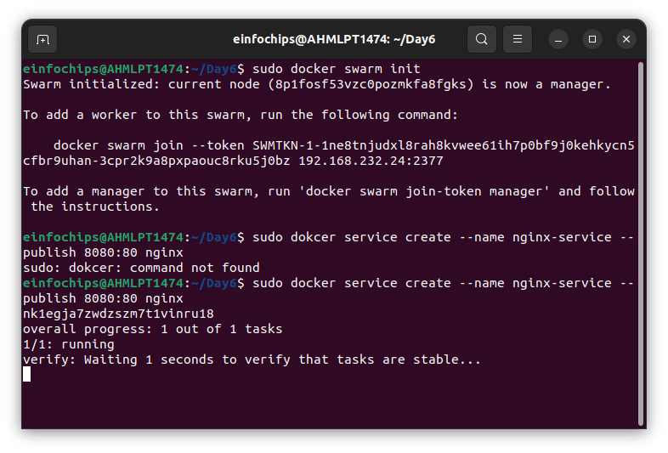

### **Step 2: Set up Kubernetes Using Minikube**

#### **2.1 Start Minikube**

# Start Minikube

minikube start

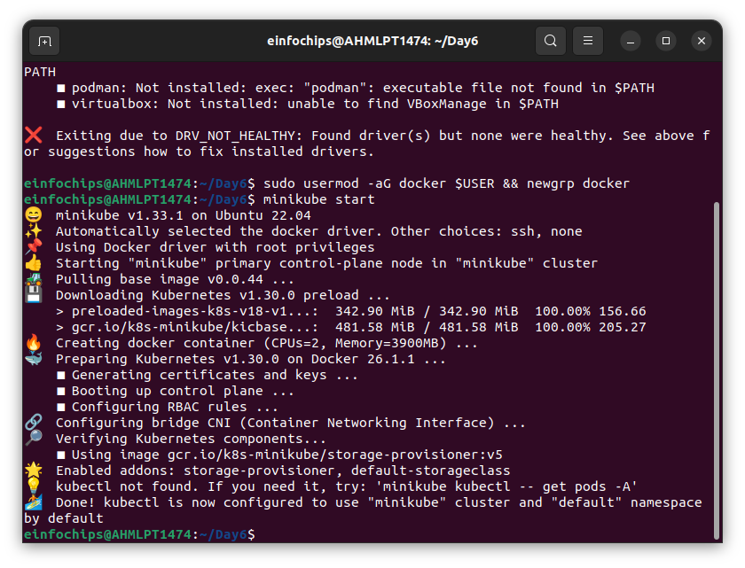

#### **2.2 Deploy a Web App on Kubernetes**

Create a deployment file named webapp-deployment.yaml:

apiVersion: apps/v1

kind: Deployment

metadata:

name: webapp

spec:

replicas: 3

selector:

matchLabels:

app: webapp

template:

metadata:

labels:

app: webapp

spec:

containers:

- name: webapp

image: nginx

ports:

- containerPort: 80

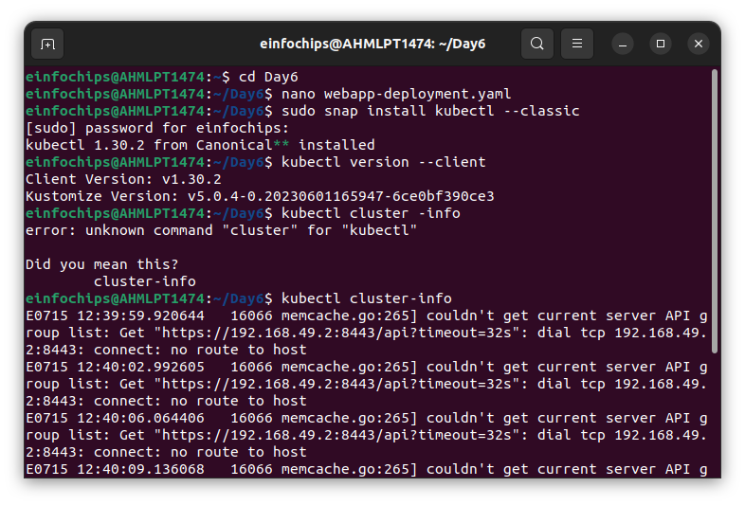

Apply the deployment:

kubectl apply -f webapp-deployment.yaml

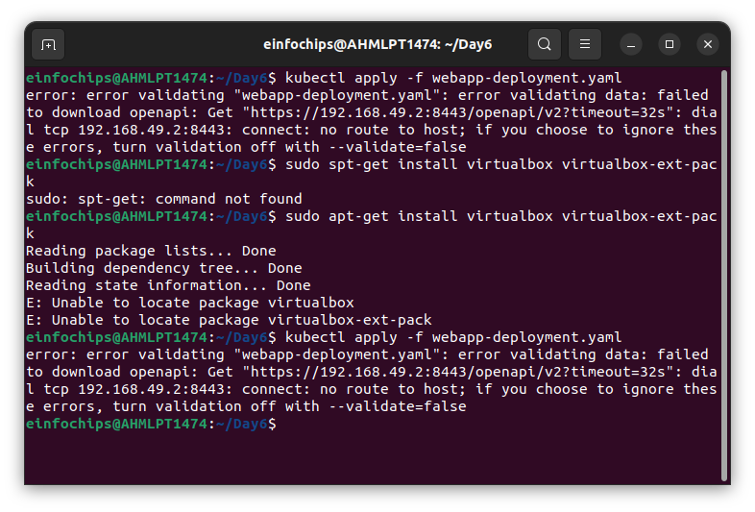

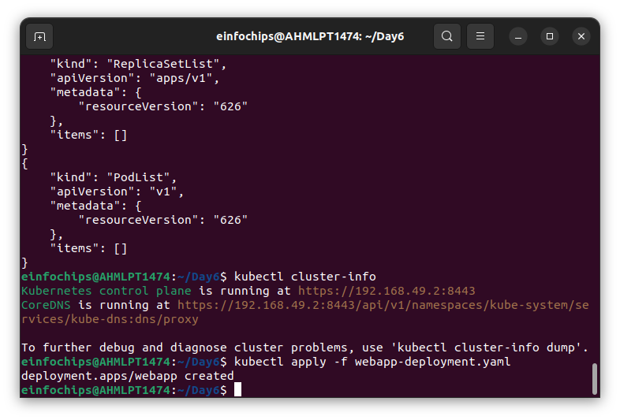

#### **2.3 Expose the Deployment**

kubectl expose deployment webapp --type=NodePort --port=80

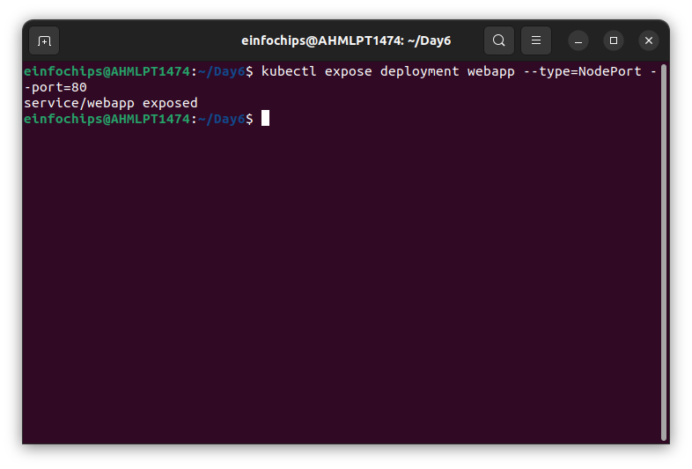

### **Step 3: Deploy a Web Application Using Docker Compose**

#### **3.1 Create a docker-compose.yml File**

version: '3'

services:

web:

image: nginx

ports:

- "8080:80"

volumes:

- webdata:/usr/share/nginx/html

volumes:

webdata:

#### **3.2 Deploy the Web Application**

# Deploy using Docker Compose

docker-compose up -d

### **Step 4: Use a Single Shared Volume Across Multiple Containers**

#### **4.1 Update docker-compose.yml to Use a Shared Volume**

version: '3'

services:

web1:

image: nginx

ports:

- "8081:80"

volumes:

- shareddata:/usr/share/nginx/html

web2:

image: nginx

ports:

- "8082:80"

volumes:

- shareddata:/usr/share/nginx/html

volumes:

shareddata:

#### **4.2 Deploy with Docker Compose**

# Deploy using Docker Compose

docker-compose up -d

### **Step 5: Automate the Entire Process Using Advanced Shell Scripting**

#### **5.1 Create a Shell Script deploy.sh**

#!/bin/bash

# Initialize Docker Swarm

docker swarm init

# Create Docker Swarm Service

docker service create --name nginx-service --publish 8080:80 nginx

# Start Minikube

minikube start

# Create Kubernetes Deployment

kubectl apply -f webapp-deployment.yaml

# Expose the Deployment

kubectl expose deployment webapp --type=NodePort --port=80

# Deploy Web App Using Docker Compose

docker-compose -f docker-compose-single-volume.yml up -d

echo "Deployment completed successfully!"

#### **5.2 Make the Script Executable**

# Make the script executable

chmod +x deploy.sh

#### **5.3 Run the Script**

# Run the deployment script

./deploy.sh